## Interview prep:

## Square point interview (Yuejing):

Brief introduction to square point:

* square point is working on a wide range of strategies.
* even single stock higher frequency strategies
* to lower frequency CTA type of strategies
* also including the macro strategies
* systematic macro strategies.
* square point is a much bigger platform

## Square point interview (French guy):

Mostly trading future equities as well as FX. We trade cash equities, credit, treasury swaps. Frequency from couple of days to months. Everybody does both research and trading. The main idea is to develop new strategies.

* How are things at Caxton.
* Why do you want to leave.
  + My main focus is on systematic trading strategies.
  + I was brought on Caxton initially to develop systematic trading strategies
  + But it turned out that they have relatively small pocket for this
  + What I’m developing is very valuable
  + Hope to find a prestigious quantitative hedge fund like ABC.
    - Team working
    - Scientific approach
    - Persistence
    - practical
* Tell me about the type of strategies you’re developing.
  + My specialty is mainly on directional interest rate strategy and directional FX. Able to build RV system on top of directional system.
    - Directional rates: treasury swap or futures
      * Gauge that tells you if the central bank should be easing or tightening policies.
    - Universe of coverage:
      * G10 + key EM markets
      * Average holding period of 8 weeks.
    - FX strategies
      * Prop model that tells you how much pressure in FX market will be there over the next 3 months.
      * FX market is described as the aggregation of different type of flows. E.g. current account, financial account flows (equity, FDI), speculative, hedging flows, banking flows, reserves etc.
      * When money leaves the DW: TIC; FCI; DW monetary growth
      * Build a prop model to estimate the flow over the next 3 months

## Three strengths:

* Curiosity
* Teamwork
* Able to get things done quickly

## Three weaknesses:

* Shy
* Not a great seller
* Slow in making decisions

## Technical question:

* Dimension reduction techniques:
  + Simple weighted average
    - Simple, transparent, easy to interpret

## Other competency question (STAR structure):

* Math modelling contest:
  + Situation: Imagine you have 100 people in an office; 50 of them are plotting a crime, the other 50 people were innocent. What you’re given: 5 people in this group that are criminals; also you have the chatting history of all these 100 people. Chatting history has been sorted into 10 buckets.
  + Task: I was responsible for figuring out an algorithm to find out the possibility of each individual in that room a criminal.
  + Action: I solved this problem on following steps:
    - Since I was given 5 people that are known criminal, I analyzed the chatting history of those 5 people to figure out what topics are most relevant and what topics are not.
    - I used a scoring method to figure out who are the most related to those topics
    - Used a page rank algorithm to find out who are the most connected people, they are the leaders.
  + Result: I solved this problem through very efficient and quick method.

## Why do you want to join MAN AHL:

* Admire its values
  + Persistence
  + Passion
  + Practical
  + scientific
  + collaboration

## 2020-10-9 Rokos job (with head hunter):

* Is it model driven with discretionary overlay
* Are you doing the fundamental thing as well, combined with systematic stuff?

## 计算机术语：

* Argument 变量
* Opening/closing bracket 括号
* Statement: 行; all expressions are statement
* Assignment statement: 赋值语句
* Methods = function
* Strong typing 需要定义type: C++
* Public, private: there is no private variable in python, you can access to any members at any time
* Generator: generator is a python function that returns an iterable; yield: return 1 variable a time; next
* List comprehension: list comprehension is a one line function to create a list
* Lambda: a one line anonymous function
* Reduce: reduce(func,seq)第一次取前两个，然后第二个和第三个。。。, map, zip
* Operator: 加减符号的统称
* Incrementing/decrementing: counter+=1
* Colon: 冒号;Semi colon:分号; Tilde: 波浪号; Parentheses: 小括号; Square bracket: 中括号; Curly bracket: 大括号; !: exclamation mark
* Marked for destruction: 用完毁灭
* Quartile: 分位数
* Transpose: 转置
* Attribute: 属性
* Staticmethod: defining methods that don’t access the instance data. Doesn’t receive the first implicit argument at all.
* Eigenvalue; eigenvector; characteristic function; orthogonal; quadratic function; outlier;
* Heteroscedasticity 异方差; collinearity; structural break; x explanatory variable; dependent variable; goodness of fit; White test
* Python modules: pandas; numpy; sklearn(linear model); statsmodel(loess analysis); matplotlib;
* PEP8: PEP8 is a coding convention; a set of recommendation to write python more readable.
* Induction
* Dynamic programming

Embankment Capital：

* Embankment capital was a hedge fund start-up led by ex-Goldman Sachs chief FX economist.
* We’re developing systematic macro strategies in G10/EM FX market.
* When I joined the team we only had 3 strategies in place, I was there to significantly grow the strategy universe. Started from the most basic ones like carry and momentum strategies. Extended to current account; valuation; taylor rule based; capital flows; behaviour.
* The core business was sold to Rokos Capital Management.
* Investment has the same attributes same with math. It is extremely concise, and elegant if you understand it well and some people have the natural ability to understand it very and I’m one of those people. For those don’t it is rather messy. One of the most elegant relationship I found is exchange rate and current account balance. When FX is expensive you have current account balance worsen quickest and you can say the first order derivative of current account balance is the most negative. And that will put pressure on the exchange rate and it starts to drop. When the current account is most negative, the first order derivative of exchange rate is smallest.

## 面试要领：

* 要找跟现在工作完全没有关系的工作基本已经不可能。面试的时候应该直接放弃无关的工作，比如很quant的，不够macro的
* 选择对冲基金的标准:
  + Big name (Goldman Sachs, Morgan Stanley, Credit Suisse, BNP Paribas, Millennium, Elliot, Two sigma, D.E. Shaw, AQR, Capula, PIMCO, Element, Winton, Brevan howard, Tudor, UBS , Aspect capital, Balyasn, Autonomy, Point 72, Leman brothers, Rothschild, Citi, Soros, BlackRock, Man AHL, Bluecrest, Bridgewater, Citadel, Caxton, HSBC, Square Point)
  + 老板是否愿意传授 ()
  + 公司整体业绩 （Omni）
* 找工作是漫长而痛苦的过程，在这个过程中无需太多顾虑。减少不必要的思考，原因是思考浪费很多时间并且往往是无用功。把自己的优势，劣势，能力，每个方面的着重点应该在1 pager以内（80/20法则。80%的面试题应该在20%的时间内准备完）。如果这个工作需要准备的更多，证明我也许做不了。人生就其实很复杂，只能先浅后深，先易后难。

数学复习内容(先易后难，先背诵后思想)

1. PCA
2. Linear regression
   1. OLS prove
      1. Univariate: b= cov(x,y)/var(x)
      2. Multivariate: Y=X.BETA + u
         1. U=Y-X.BETA. Ut * U = … <http://www3.grips.ac.jp/~yamanota/Lecture%20Note%204%20to%207%20OLS.pdf>
   2. Assumptions
      1. Linearity: linear relationship between dependant and explanatory
      2. Zero conditional mean: E(u|X)=0, x and u are not correlated. Exogenous.
      3. Non perfect collinearlity:
         1. Doesn’t affect prediction
         2. Coefficient estimates can be different from true value
         3. Can remove it or use ridge regression
      4. Homoskedasticity: Var(u|X)=constant, Cov(ui,uj)=0: var-covar matric should be identity matrix
         1. Standard errors are biased
         2. Estimator is not biased
         3. Solution: weighted ols: find a P so that Pu is homoscedasticity.
3. Probability
   1. Normal distribution
      1. Fumula: normal distribution： 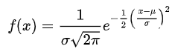； poisson distribution: ; binomial: C(n,x)p^x*(1-p)^(n-x)
   2. 绿皮书概率部分做题技巧：
      1. 数学归纳法 （做一件事几百次的时候经常用）
      2. 数列问题：技巧在于如何转化为数列问题。精髓在于前后项之间有关联（gambler’s game）
      3. 对称性 （A,B轮流做什么的时候经常用）。经常用到设未知数
   3. Multivariate probability
      1. 概率就是x,y和概率密度函数围成的面积
      2. 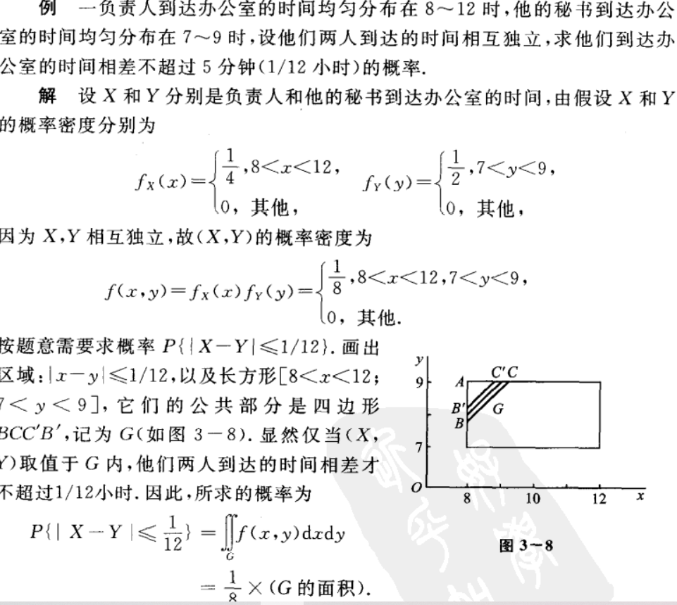
      3. 极坐标：https://www.youtube.com/watch?v=I2Z6K_g5kpc
         1. 关键在找出r ， 角 ： 画图法，先确定角，再确定半径
      4. 名词：joint distribution; conditional distribution; probability density function
      5. Distribution of function of 2 variables： 核心：面积法，卷积公式
         1. Z=X+Y (卷积公式，convolution formula)
            1. 要领：只要记住古典型就能记住啦：
            2. 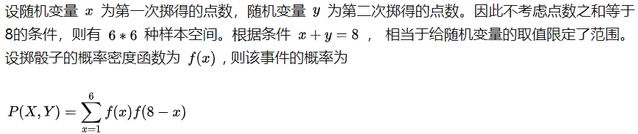

重要结论：可以用极坐标解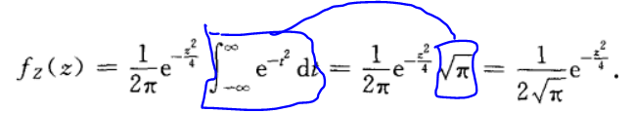

画图例题：

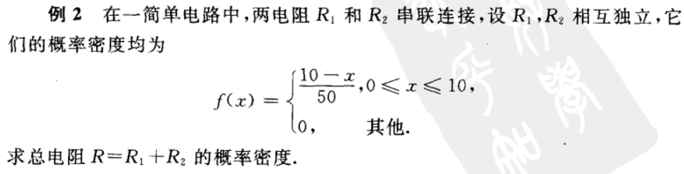

（这道题用画图做，立方体减金字塔）

几何形概率题：<https://www.jianshu.com/p/83147d263ad1>

要领：当x,y都是uniform分布的时候用画图的方式解题的概率非常大！

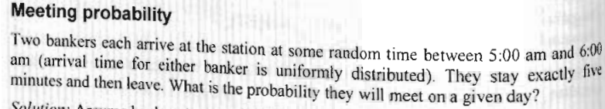

等比数列求和公式：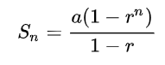

方差：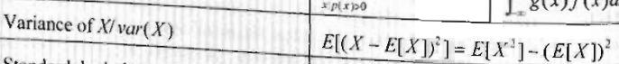

* + - 1. 贝叶斯：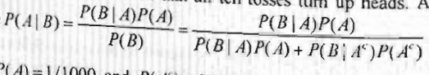
      2. 期望：
         1. 几何分布的期望是1/p,p是停止的概率
         2. 算期望的高级方法：设indicator function（每个事件是相互独立的）

1. Markov chain
   1. 概率矩阵每一行加一起都是1
   2. 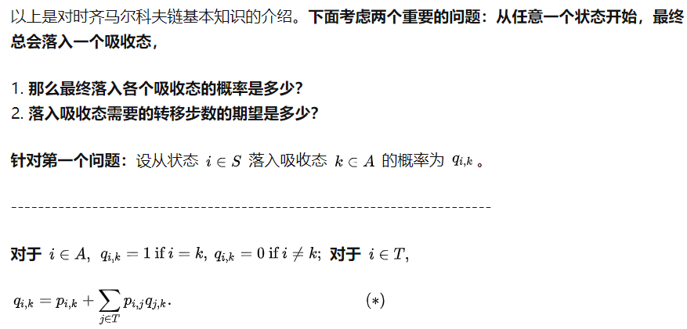
      1. 吸收状态是概率矩阵里1的项（题目中游戏停止的条件）。从某非吸收状态到吸收状态可以用列方程求解。
      2. 从任一状态到吸收态的概率为以下之和：
         1. 直接到吸收态的概率
         2. 先到另一非吸收态，在由那个状态到吸收态的概率。
      3. 解题的时候需要设未知数：每个非吸收态到吸收态的概率为x,y,z…然后解方程组。
   3. 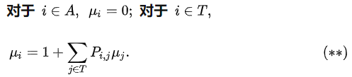
      1. 从某一态到吸收态需要的steps的平均步数：
         1. 需要解方程组：
            1. 设每一个态到吸收态的平均步数为u1,u2,u3…
            2. 解方程组。
2. 随机过程
   1. Martingale
      1. 离散同样适用
      2. 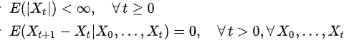鞅的定义
      3. 停时问题：
         1. 不懂的话看这个：<https://en.wikipedia.org/wiki/Optional_stopping_theorem>
   2. Dynamic programming:
      1. Card game, expected profit: looks like an American option.
         1. 技巧： 倒着想：先考虑boundary的情况： boundary + recursively
   3. Ito lemma:
      1. 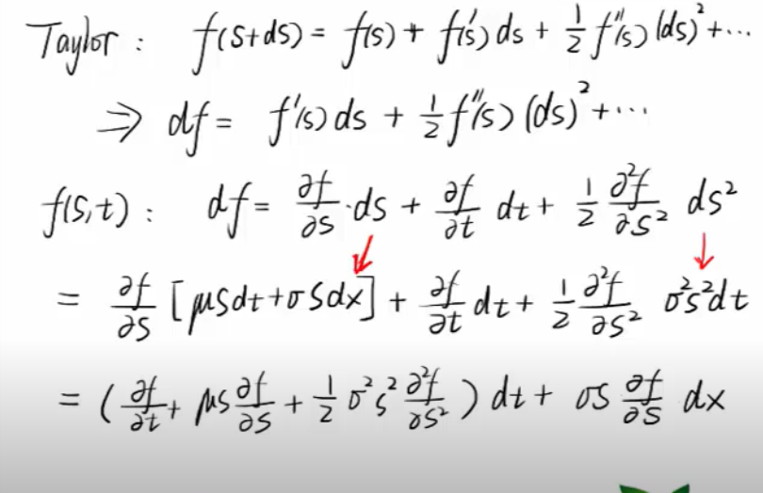
3. Option pricing
   1. Biniomial tree
      1. Martingale: conditional expectation of all future values is the current value
      2. 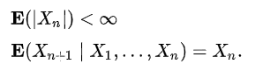
      3. Under risk neutral measure, discounted asset price is a martingale
         1. Given discounted S(t) is a martingale: E(S(t)*e^(-rt)) = S(0), also E(S(t)*e^(-rt)) = e^(-rt)*(S*p*u+S*(1-p)*d) => p=(e^(rt)-d)/(u-d)
         2. Under this p, all discounted price of derivative are martingale as well.
   2. Greeks
      1. 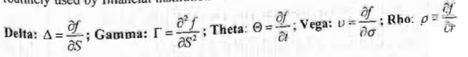
4. Sorting algo
   1. Big O
   2. Divide and conquer
5. Bond math
   1. Mac duration: duration is the weighted average maturity of cashflows: 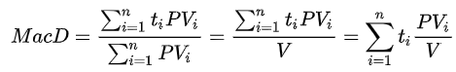
6. Cholesky decomposition
   1. Generate correlate variable.
7. Multi-threading:
   1. <https://medium.com/towards-artificial-intelligence/the-why-when-and-how-of-using-python-multi-threading-and-multi-processing-afd1b8a8ecca>